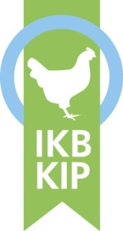
Please note!
Hygiene protocol

On this farm, we contribute to safe and healthy poultry meat. To prevent the introduction/spread of animal/bird diseases and pathogens, the following hygiene regulations apply to visitors (anyone entering the farm premises) :

- Visitors should park in the available car park in front of the boundary of the farm premises.

- Visitors should not enter the farm premises without the permission of the poultry farmer.

- Visitors should not take ‘their own’ materials and equipment with them into the barn without the permission of the poultry farmer.

- Visitors should abide by the instructions of the poultry farmer.

If the visitor enters the clean part of the farm, the following additional hygiene regulations apply:

- On arrival at the hygiene lock, the visitor should:
  - sign the visitors’ register;
  - become familiar with the routing of the farm (map);
  - in the changing rooms, follow the steps below;
    - Remove footwear, clothing (incl. underwear) and leave behind. Also remove jewellery and watches;
    - Personal belongings should eventually be stored in a locker or left in the unclean part of the hygiene lock;
  - in the shower area, follow the steps below;
    - Shower for at least five minutes with warm water;
    - Wash the entire body, ears and hair with soap;
    - Blow each of the nostrils empty;
  - In the changing rooms, follow the steps below;
    - Take a clean towel to dry body and hair;
    - Change into the proprietary clothing including (disposable) underwear and proprietary footwear.

- At each barn, the visitor should :
  - put on the proprietary footwear for that barn;
  - disinfect hands;
  - when leaving the barn, the visitor must remove the proprietary footwear for that barn and leave it behind.
- On leaving the hygiene sluice, the visitor should:
  - remove the proprietary clothing and proprietary footwear and leave them behind;
  - take a shower as described in step five;
  - put on his/her own clothing and footwear.

THANK YOU FOR YOUR COOPERATION!

Version 2. 26-04-2019
Sample document (Provision J14 – Annex 1.2 – Regulations for poultry farms)

